*Sameer Dehadrai*

**MySQL**

**Exercise 6**

1. Write a stored procedure by the name of Comp_intr to calculate the amount of interest on a bank account that compounds interest yearly. The formula is:- I = p (1+ r) y – p

where:-

I is the total interest earned.

p is the principal.

r is the rate of interest as a decimal less than 1, and

y is the number of years the money is earning interest.

Your stored procedure should accept the values of *p*, *r* and *y* as parameters and insert the Interest and Total amount into tempp table.

Ans:

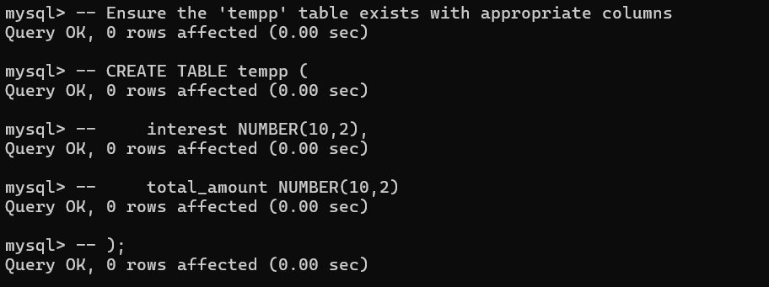

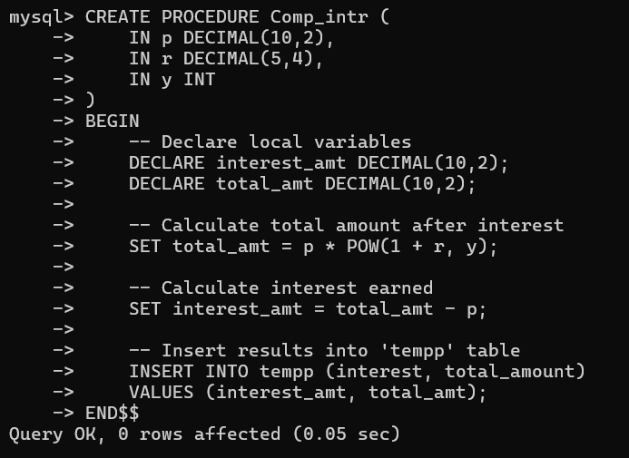

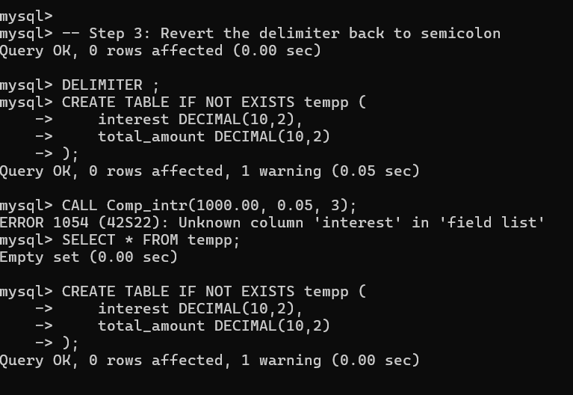

2. Create a stored function by the name of Age_calc. Your stored function should accept the date of birth of a person as a parameter. The stored function should calculate the age of the person in years. The stored function should return the age in years.

